African Resin Burl
Afromosia
Alaska Yellow Cedar
American Elm
Amboyna Burl
Andira
Anigre
Aromatic Cedar
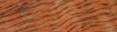
Australian Tiger
Bali
Bamboo
BeesWing Narra

Bethlehem Olivewood
Birdseye Maple
Black & White Ebony
African Blackwood
Black Palm
Bloodwood
Bolivian Rosewood
Bocote
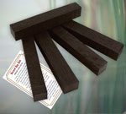
Ancient Bog Oak
Briar Burl
BrownHeart

Brown Mallee
Brown Mallee Burl
Bubinga
Burmese Blackwood
Burmese Rosewood
Butternut
Camphor Burl
Camelthorn
Canarywood
Curly Anigre
Bethlehem Carob

Chakte Kok
Chakte Viga
Cinnamon
Cocobolo
Coffee Tree
Coolibah Burl
Curly Eucalyptus
Curly Maple
Curly Myrtle
Desert Ironwood
Ebiara
Ebony

Eucalyptus Burl
Eucalyptus Gum Vein
Bird's Eye Eucalyptus
Flame Birch
Granadillo
Grey Box Burl
Holly
Goncalo Alves
Honduran Mahogany
Honduran Rosewood
Honey Locust
East Indian Rosewood

IPE (Brazilian Ironwood)
Iroko (African Teak)
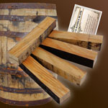
Jack Daniels Barrel
Jatoba/Brazilian Cherry
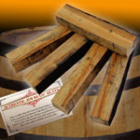
Jim Beam Barrel
Katalox
Kingwood
Curly Koa
Ancient Kauri
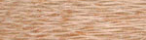
Lacewood
Lemonwood

Leopardwood
Lignum Vitae
Antique Long Leaf Pine
Lyptus
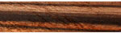
Macassar Ebony
Madrone Burl
Philippine Mahogany
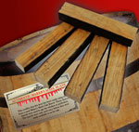
Makers Mark Barrel
Makore Pen Blank
Mango
Maple Burl
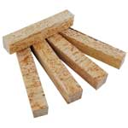
Masur Birch
Marblewood
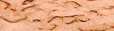
Masur Birch
Matai Burl
Mexican Redheart
Monkeypod
Mora
Munn Ebony
Osage Orange
Olivewood
Padauk

Peruvian Nogal
Pheasant Wood
Pink Ivory
Curly Pyinma
Purpleheart
Red Elm
Red Mallee Burl
Red Palm
Red River Gum
Roasted Oak
Santos Mahogany
Sapele

Quilted Sapele
Shedua
Snakewood
Spanish Cedar
Spalted Tamarind
Sycamore
Tambooti
Tazmanian Blackwood
Teak
Thuya Burl
Tulipwood
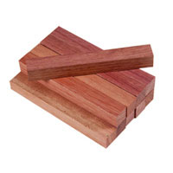
Tropical Wenga

Wenge

Curly White Oak
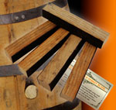
Wild Turkey Barrel
Yellow Box Burl
Yellowheart
Zebrawood
Ziricote
Stabilized Woods
S- Amboyna Burl
S- Spalted Beech
S-Black Ash
S-Black Palm
S-Boxelder Burl
S-Buckeye Burl
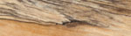
S- Spalted Butternut
S- Flaming Boxelder
S- Eucalyptus Burl
S- Cherry Burl
S- Spalted Hackberry

S-Curly Koa
S- Spalted Locust
S- Curly Mango
S- Ambrosia Maple
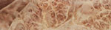
S- Maple Burl
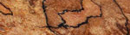
S- Spalted Maple
S- Spalted Myrtle
S- Spalted Pecan
S- Spalted Tiger Oak

